

**Subject: Software Engineering**

**Subject code: IT632**

**Final Assignment - Deliverable Code : 01 to 06**

Date of submission: 02-05-2023

Due date of submission:02-05-2023

**Name: Dev Adnani**

**Topic: Zoom Video Conference Application**

Index

**1: System/Problem specification 4**

**2: SRS 9**

1.1 Purpose: 10

1.2 Scope: 11

1.3 Definitions, Acronyms, and Abbreviations: 12

1.4 References 13

1.5 Overview 14

2. The Overall Description 15

2.1 Product Perspective: 15

2.1.1 System Interfaces: 16

2.1.2 User Interfaces: 16

2.1.3 Hardware Interfaces: 16

2.1.4 Software Interfaces: 16

2.1.5 Communications Interfaces: 17

2.1.6 Memory Constraints: 17

2.1.7 Operations: 17

2.1.8 Site Adaptation Requirements: 17

2.2 Product Functions: 18

2.3 User Characteristics: 19

2.4 Constraints: 19

2.5 Assumptions and Dependencies: 20

2.6 Apportioning of Requirements: 20

3. Specific Requirements 21

3.1 External interfaces: 21

3.2 Functions: 21

3.3 Performance Requirements: 21

3.4 Logical Database Requirements: 22

3.5 Design Constraints: 22

3.5.1 Standards Compliance: 22

3.6 Software System Attributes: 22

3.6.1 Reliability: 22

3.6.2 Availability: 22

3.6.3 Security: 23

3.6.4 Maintainability: 23

3.6.5 Portability: 23

3.7 Organizing the Specific Requirements 24

3.7.1 System Mode 24

3.7.2 User Class: 24

3.7.3 Objects: 24

3.7.4 Feature: 24

3.7.5 Stimulus: 24

3.7.6 Response: 25

3.7.7 Functional Hierarchy: 25

3.8 Additional Comments: 25

**3: Agile Methodology 26**

3.1: Agile Methodology 26

**3.2: Project Schedule 27**

**4: SA/SD 29**

4.1: System Architecture 29

4.2: System Design 29

4.3: DFD Level 0 30

4.4: DFD Level 1 31

4.5: DFD Level 2 32

**5: UML Diagrams 33**

5.1: Activity Diagram 33

5.2: Use Case Diagram 34

5.2.1 : Use Case Diagram (Textual Format) 35

5.3: Sequence Diagram 41

5.4: Class Diagram 42

**6 : Test Cases 43**

1 : Log in to Zoom account 44

2 : Schedule meeting 45

3 : Join Meeting 46

4 : Generate Meeting Link and Access Code 47

5 : Send Meeting Invite 48

6 : Enable Audio and Video 49

7 : Start Meeting 50

8 : Share Screen 51

9 : Record Meeting 52

10 : Transcribe Meeting 53

11 : End Meeting 54

12 : Leave Meeting 55

13: Change Video Layout 56

14 : Change Meeting Settings 57

15 : Mute All Participants 58

16 : Change Audio Settings 59

17 : Manage Participants 60

18 : Share Video Clip 61

19 : Share Whiteboard 62

20 : Share Virtual Background 63

# 1: System/Problem specification

Introduction:

In recent years, remote work and online learning have become increasingly prevalent, and the need for virtual communication tools has become more important than ever before. Among these tools, the Zoom video conference app has emerged as a leading solution for virtual meetings, webinars, online classes, and more. Since its inception in 2011, Zoom has gained massive popularity and has become a staple for remote teams, educators, and businesses worldwide. The app offers an array of features that enable seamless video and audio communication, screen sharing, virtual backgrounds, and meeting management. However, as with any technology, the Zoom app is not without its challenges. Security and privacy issues, reliability, compatibility, and bandwidth and internet connection problems are among the challenges that Zoom has faced. In this write-up, we will explore the system specification and problem statement of the Zoom video conference app in-depth, delving into its features, advantages, and challenges.

Zoom is a video conferencing app that allows people to have virtual meetings, conferences, webinars, and online classes. It has become a go-to app for remote work and distance learning, especially during the Covid-19 pandemic.

System Specification:

1. Video and Audio Communication: The Zoom app is designed to provide seamless and high-quality video and audio communication. The app uses a combination of audio and video codecs to enable high-quality audio and video communication even at low bandwidths. Zoom supports video resolutions up to 720p and 1080p, depending on the user's device and internet speed. The app also features noise cancellation and echo suppression technologies, which ensure clear and uninterrupted audio communication.
2. Screen Sharing: Screen sharing is one of the most essential features of the Zoom app, enabling users to share their desktop, app window, or any other content on their screen with other participants in the meeting. This feature is useful for presentations, online classes, and remote troubleshooting. The app also supports the sharing of audio, making it easy to play audio files during a presentation or share sound from a video.
3. Virtual Backgrounds: Zoom allows users to set virtual backgrounds to hide their physical environment during the video call. This feature is useful for maintaining privacy and reducing distractions during the meeting. Users can choose from a variety of preset backgrounds or upload their own custom backgrounds.
4. Meeting Management: The Zoom app provides several features that allow meeting hosts to manage the meeting effectively. The host can control who joins the meeting, mute or unmute participants, and enable or disable features like screen sharing and virtual backgrounds. The host can also record the meeting for later reference or sharing with absent participants. Additionally, Zoom offers breakout rooms, which allow the host to split participants into smaller groups for discussions or activities.
5. User Interface: The Zoom app has a simple and intuitive user interface that makes it easy for users to join and manage meetings. The app is available on multiple platforms, including Windows, Mac, iOS, and Android, and it is also accessible through web browsers. The app's interface is consistent across platforms, making it easy for users to switch between devices and platforms without confusion.
6. Customization: The Zoom app offers several customization options, allowing users to tailor the app to their preferences. For example, users can change their virtual background, set up custom meeting backgrounds, and customize the app's layout and notifications.
7. Integration: Zoom integrates with several third-party apps and services, allowing users to streamline their workflows and enhance their productivity. For example, users can integrate Zoom with scheduling apps like Calendly, productivity tools like Asana and Trello, and video recording and editing software like Camtasia.
8. Accessibility: Zoom strives to make its app accessible to users with disabilities. The app supports closed captioning, keyboard shortcuts, and screen reader software, among other accessibility features.
9. Reliability: Zoom's reliability has been a concern in the past, with reports of frequent crashes and connectivity issues. However, the company has invested in improving its infrastructure and addressing these issues. The app now has a robust network of servers and data centers, ensuring high availability and minimal downtime.
10. Pricing and Plans: Zoom offers a range of pricing plans, from a free basic plan to enterprise-level plans with advanced features and support. The company's pricing structure is transparent and predictable, with no hidden fees or charges.

Problem Specification:

1. Zoom Fatigue: As the pandemic forced many people to work and socialize remotely, the overuse of virtual communication tools like Zoom led to a phenomenon known as "Zoom fatigue." Users may experience mental exhaustion and burnout from the constant stream of virtual meetings, which can affect their productivity and well-being.
2. User Limits: The Zoom app has limits on the number of participants that can join a meeting, depending on the user's plan. This limit may be a challenge for large organizations or events that require a higher number of participants.
3. Integration with Other Tools: While the Zoom app offers several integrations with other tools, some users may find it challenging to integrate the app with their existing workflow or may require additional integrations that are not available.
4. Language Barriers: The Zoom app is available in several languages, but users who do not speak the language of the meeting or the app may face communication challenges, leading to misunderstandings or misinterpretations.
5. Accessibility: The Zoom app has several accessibility features, such as closed captioning and screen reader compatibility, but some users may still encounter accessibility challenges, such as those with visual or hearing impairments.
6. User Behavior: While the Zoom app offers several features that allow meeting hosts to manage the meeting effectively, users may encounter challenges if other participants do not follow proper meeting etiquette, such as speaking over each other, interrupting, or not muting themselves.
7. Recording and Storage: The Zoom app allows users to record meetings and store them for future reference, but users may encounter challenges with the size of the recordings and storage limits, especially for longer meetings.
8. Learning Curve: While the Zoom app has a simple and intuitive user interface, users who are new to the app may require time to learn its features and functionality, leading to a learning curve that may affect their productivity and efficiency.

Conclusion :

In conclusion, the Zoom video conference app is a powerful tool for remote communication and collaboration, but it also faces several challenges that may affect its functionality and user experience. These challenges include security and privacy issues, reliability, compatibility isues, bandwidth and internet connection problems, user interface, meeting management, audio and video quality, pricing, user limits, integration with other tools, language barriers, accessibility, user behavior, recording and storage, and the learning curve.

Despite these challenges, the Zoom app has become an essential tool for individuals, businesses, and organizations worldwide, especially during the Covid-19 pandemic. Its features and functionality have enabled people to stay connected and collaborate remotely, leading to increased productivity and efficiency.

To address the challenges facing the Zoom app, the company has taken several steps to improve its functionality, security, and user experience. For example, the company has introduced new security features to address privacy concerns, increased server capacity to improve reliability, and added new features and integrations to enhance its functionality.

Moving forward, it will be essential for Zoom to continue to listen to user feedback and address the challenges facing the app to provide a seamless and secure virtual communication experience. As remote work and virtual communication become increasingly common, tools like Zoom will continue to play a crucial role in enabling people to connect and collaborate, and it is essential to ensure that they are reliable, secure, and user-friendly.

# 

# 2: SRS

Zoom is a popular video conferencing app that has become essential for remote communication and collaboration, especially during the Covid-19 pandemic. The app allows users to participate in virtual meetings, webinars, and online events from anywhere in the world, making it easy for people to stay connected and work together remotely. The purpose of this document is to provide a detailed specification of the Zoom app, including its functional and non-functional requirements, system architecture, user interface, data management, testing and quality assurance, deployment and maintenance procedures, legal and regulatory requirements, and glossary of key terms.

In this document, we will discuss the key features and functionalities of the Zoom app, including its video and audio conferencing capabilities, screen sharing and recording features, chat and messaging functions, integration with other tools, security and privacy features, and pricing plans. We will also highlight the challenges facing the Zoom app, such as security and privacy issues, reliability, compatibility issues, bandwidth and internet connection problems, user interface, meeting management, audio and video quality, pricing, user limits, integration with other tools, language barriers, accessibility, user behavior, recording and storage, and the learning curve.

Overall, this document aims to provide a comprehensive specification of the Zoom app, which will help developers and users understand its features, requirements, and limitations. By addressing these challenges and improving the app's functionality, security, and user experience, Zoom can continue to be a valuable tool for remote communication and collaboration in the future.

## 1.1 Purpose:

The purpose of the Zoom video conferencing app is to provide a reliable, easy-to-use, and comprehensive platform for remote communication and collaboration. The app is designed to overcome the challenges of distance and time, allowing people to connect and work together from anywhere in the world. With the rise of remote work, distance education, and virtual events, the need for a robust and user-friendly video conferencing tool has become more crucial than ever.

The primary goal of the Zoom app is to provide a seamless and secure user experience, enabling people to participate in virtual meetings, webinars, and online events with ease. By providing high-quality audio and video conferencing, screen sharing and recording, chat and messaging, whiteboarding, virtual backgrounds, breakout rooms, scheduling and calendar integration, integration with other tools, security and privacy features, and pricing plans, the app aims to cater to the needs of individuals, businesses, and organizations of all sizes.

The broader purpose of the Zoom app is to facilitate remote work, distance education, and virtual events, while promoting collaboration, productivity, and innovation. The app enables people to work and learn in a flexible and dynamic environment, which can enhance their creativity and motivation. By fostering a sense of community and connection, the app can help to combat isolation and promote social interaction in a virtual setting.

Overall, the purpose of the Zoom app is to provide a comprehensive and versatile platform for remote communication and collaboration, which can help to bridge the gap between distance and time. The app aims to provide a reliable, user-friendly, and inclusive experience, which can support the needs of users from diverse backgrounds and industries. By empowering people to connect and collaborate virtually, the Zoom app can help to promote innovation, productivity, and growth in the digital age.

## 1.2 Scope:

The scope of the Zoom app is broad and encompasses a wide range of features and functionalities. The app is designed for use by individuals, businesses, and organizations of all sizes, and it can be used for a variety of purposes, including team meetings, webinars, virtual events, distance education, and online training. The app is available on multiple platforms, including Windows, macOS, iOS, Android, and web browsers, making it accessible to users on different devices.

The key features and functionalities of the Zoom app include video and audio conferencing, screen sharing and recording, chat and messaging, whiteboarding, virtual backgrounds, breakout rooms, scheduling and calendar integration, integration with other tools, security and privacy features, and pricing plans. The app also supports multiple languages and accessibility features, making it inclusive and user-friendly for people with disabilities.

The scope of this document is to provide a detailed specification of the Zoom app, including its functional and non-functional requirements, system architecture, user interface, data management, testing and quality assurance, deployment and maintenance procedures, legal and regulatory requirements, and glossary of key terms. This document aims to help developers and users understand the features, requirements, and limitations of the Zoom app, and to provide a framework for its development and implementation.

## 1.3 Definitions, Acronyms, and Abbreviations:

Definitions:

* Zoom app: A video conferencing application developed by Zoom Video Communications, Inc.
* User: A person who uses the Zoom app to participate in virtual meetings, webinars, and online events.
* Host: A user who initiates and manages a Zoom meeting or webinar.
* Participant: A user who joins a Zoom meeting or webinar initiated by a host.
* Audio conferencing: A feature of the Zoom app that enables users to communicate with each other using voice over the internet.
* Video conferencing: A feature of the Zoom app that enables users to communicate with each other using video and voice over the internet.
* Screen sharing: A feature of the Zoom app that enables users to share their computer screen with other participants in a meeting or webinar.
* Breakout rooms: A feature of the Zoom app that enables hosts to split participants into smaller groups for discussion or collaboration.
* Virtual background: A feature of the Zoom app that enables users to replace their real background with a virtual image or video.

Acronyms:

* SRS: Software Requirements Specification
* UI: User Interface
* API: Application Programming Interface
* SDK: Software Development Kit
* QA: Quality Assurance
* UX: User Experience
* GDPR: General Data Protection Regulation

Abbreviations:

* App: Application
* Sec: Security
* Req: Requirement
* Dev: Development
* Doc: Document
* OS: Operating System
* CPU: Central Processing Unit
* RAM: Random Access Memory

## 1.4 References

* Zoom Help Center:<https://support.zoom.us/hc/en-us>
* Zoom Developer Center:<https://marketplace.zoom.us/docs/guides>
* Zoom Security Whitepaper:<https://zoom.us/docs/doc/Zoom-Security-White-Paper.pdf>
* Zoom Privacy Policy:<https://zoom.us/privacy>
* IEEE Format Reference : [Here](https://www.studocu.com/in/document/jawaharlal-nehru-technological-university-hyderabad/software-engineering/srs-template-2-ieee-format-for-the-students/25871615)

## 

## 1.5 Overview

This section of the document provides an overview of the Zoom app, including its features, benefits, and target users. The overview aims to provide a high-level understanding of the app's purpose and scope, as well as its key capabilities and value proposition.

The Zoom app is a video conferencing application that enables users to participate in virtual meetings, webinars, and online events. The app provides a range of features, including audio and video conferencing, screen sharing, recording, chat and messaging, whiteboarding, virtual backgrounds, breakout rooms, scheduling and calendar integration, integration with other tools, security and privacy features, and pricing plans.

The Zoom app is designed to cater to the needs of individuals, businesses, and organizations of all sizes, who require a reliable, easy-to-use, and comprehensive platform for remote communication and collaboration. The app aims to provide a seamless and secure user experience, enabling users to connect and work together from anywhere in the world.

The Zoom app is compatible with various devices and operating systems, including desktop and laptop computers, mobile devices, and web browsers. The app can be accessed through its website or downloaded as a desktop or mobile application. The app offers a range of pricing plans, including free, pro, business, and enterprise, to cater to the needs of users with different budgets and requirements.

Overall, the Zoom app is a versatile and powerful tool that can help to facilitate remote work, distance education, and virtual events, while promoting collaboration, productivity, and innovation. The app aims to provide a comprehensive and inclusive platform for users to connect and collaborate virtually, regardless of their location or background.

## 2. The Overall Description

## 2.1 Product Perspective:

This section of the document provides an overview of the product perspective of the Zoom app. It describes the system interfaces, hardware and software interfaces, communication interfaces, memory constraints, and operational requirements of the app.

The Zoom app is a standalone video conferencing application that can be accessed via its website or downloaded as a desktop or mobile application. The app is designed to operate on various devices and operating systems, including Windows, Mac OS, iOS, and Android. The app provides a range of features, including audio and video conferencing, screen sharing, recording, chat and messaging, whiteboarding, virtual backgrounds, breakout rooms, scheduling and calendar integration, integration with other tools, security and privacy features, and pricing plans.

#### 

#### 2.1.1 System Interfaces:

The Zoom app is designed to operate as a standalone system, without any direct integration with other systems or applications. However, the app provides APIs and SDKs that enable developers to integrate the Zoom features and functionalities into their own systems or applications. These system interfaces enable users to access the Zoom features and functionalities from within other applications or systems.

#### 2.1.2 User Interfaces:

The user interface of the Zoom app is designed to be intuitive, user-friendly, and easy to navigate. The app provides a range of UI elements, such as buttons, menus, icons, and controls, that enable users to access the different features and functionalities of the app. The app provides a range of customization options, such as virtual backgrounds, camera settings, and layout options, that enable users to personalize their virtual meeting experience

#### 2.1.3 Hardware Interfaces:

The Zoom app requires certain hardware specifications to function optimally. The minimum hardware requirements for the app are:

* CPU: Intel i5 or AMD equivalent processor
* RAM: 4 GB or higher
* Hard drive: 1 GB of free space or higher
* Webcam: Built-in or external USB webcam
* Microphone: Built-in or external microphone
* Speakers: Built-in or external speakers

The app is designed to work with various hardware interfaces, such as webcams, microphones, and speakers, to enable users to communicate and collaborate effectively.

#### 2.1.4 Software Interfaces:

The Zoom app is designed to work on various operating systems, including Windows, Mac OS, iOS, and Android. The app requires certain software specifications to function optimally. The minimum software requirements for the app are:

* Windows: Windows 7 or higher, 64-bit
* Mac OS: Mac OS X 10.9 or higher
* iOS: iOS 8.0 or higher
* Android: Android 4.0 or higher

The app provides software interfaces that enable users to access the Zoom features and functionalities from within other applications or systems. The app also provides APIs and SDKs that enable developers to integrate the Zoom features and functionalities into their own systems or applications.

#### 2.1.5 Communications Interfaces:

The Zoom app requires an internet connection to function optimally. The app uses various communication interfaces, such as Wi-Fi, Ethernet, and cellular data, to enable users to connect and communicate with each other. The app uses secure communication protocols, such as SSL/TLS, to ensure the privacy and security of user data.

#### 2.1.6 Memory Constraints:

The Zoom app has certain memory constraints that need to be taken into consideration. The app requires a certain amount of free disk space to be available for recording and storing meeting data. The app also has certain memory requirements for video and audio processing, which can impact the performance of the app if not met.

#### 2.1.7 Operations:

The Zoom app is designed to operate in a wide range of scenarios and environments. The app can be used for virtual meetings, webinars, online classes, and other collaborative activities. The app provides a range of features and functionalities that enable users to communicate and collaborate effectively, regardless of their location or device.

The app can be used for one-on-one meetings, as well as for group meetings with up to 1,000 participants (depending on the pricing plan). The app provides various scheduling and calendar integration features that enable users to schedule and join meetings easily. The app also provides a range of security and privacy features, such as end-to-end encryption, password protection, and waiting rooms, that ensure the safety and confidentiality of user data.

#### 2.1.8 Site Adaptation Requirements:

The Zoom app can be adapted to different sites and environments, depending on the specific needs and requirements of the users. The app provides a range of customization options, such as virtual backgrounds, camera settings, and layout options, that enable users to personalize their virtual meeting experience. The app also provides APIs and SDKs that enable developers to integrate the Zoom features and functionalities into their own systems or applications, thereby adapting the app to specific site requirements.

## 2.2 Product Functions:

The Zoom app provides a range of functions that enable users to communicate and collaborate effectively. These functions include:

* Video conferencing: The app enables users to have high-quality video conferences with up to 1,000 participants (depending on the pricing plan).
* Audio conferencing: The app enables users to have audio conferences with participants who do not have video capabilities.
* Screen sharing: The app enables users to share their screens with other participants, which is useful for presentations, demonstrations, and remote support.
* Recording: The app enables users to record their meetings for future reference or for participants who could not attend the live session.
* Chat: The app provides a chat feature that enables participants to communicate via text during the meeting.
* Virtual backgrounds: The app provides a feature that enables users to change their backgrounds, which is useful for privacy, branding, or entertainment purposes.
* Breakout rooms: The app enables users to create breakout rooms, which are separate virtual rooms where smaller groups can have discussions or activities.

## 

## 2.3 User Characteristics:

The Zoom app is designed for users who need to communicate and collaborate remotely, regardless of their location or device. The users may have different levels of technical proficiency, from beginners to advanced users. The app is suitable for a range of use cases, such as online classes, business meetings, webinars, virtual events, and social gatherings.

## 2.4 Constraints:

The Zoom app is subject to various constraints, such as:

* Internet connectivity: The app requires a stable and high-speed internet connection for optimal performance.
* Hardware and software compatibility: The app may have compatibility issues with some devices or operating systems.
* Pricing: The app offers various pricing plans with different features and limitations, which may constrain the users' choices.
* Regulatory and legal requirements: The app must comply with various regulations and laws regarding data privacy, security, and accessibility.

## 

## 2.5 Assumptions and Dependencies:

The Zoom app assumes that:

* The users have access to a stable and high-speed internet connection.
* The users have compatible devices and software.
* The users have the necessary skills and knowledge to use the app effectively.
* The app complies with relevant regulations and laws.

The app depends on:

* Third-party services and technologies, such as cloud computing, content delivery networks, and APIs.
* The users' feedback and suggestions for continuous improvement.

## 2.6 Apportioning of Requirements:

The requirements for the Zoom app can be apportioned into different phases or releases, depending on the priorities and resources of the development team. Some possible apportioning strategies are:

* Basic functionality first: Develop the core features and functionalities of the app, such as video conferencing, audio conferencing, and screen sharing, before adding more advanced features.
* User feedback-driven: Prioritize the features and functionalities that are most requested or needed by the users, based on their feedback and suggestions.
* Incremental improvements: Release frequent updates and improvements to the app, based on a continuous improvement process, rather than waiting for major releases.
* Platform-specific features: Develop features and functionalities that are specific to certain platforms or devices, such as mobile apps, desktop apps, or web apps, depending on the target audience and use cases.
* Integration with third-party apps: Develop integrations with other apps or services that are commonly used by the users, such as Google Drive, Dropbox, or Salesforce.
* Accessibility and security: Improve the accessibility and security of the app by complying with relevant standards and guidelines, such as WCAG 2.1, HIPAA, or GDPR.
* Performance and scalability: Improve the performance and scalability of the app by optimizing the code, using caching and load balancing techniques, and leveraging cloud computing resources.

The apportioning of requirements should be based on a clear understanding of the users' needs, the market trends, and the available resources, and should be communicated and prioritized effectively to the development team and stakeholder

## 3. Specific Requirements

## 3.1 External interfaces:

The Zoom Video Conference App will have the following external interfaces:

* User Interface: The app will have a user interface that is intuitive, easy to use, and visually appealing. It should provide users with the ability to easily join meetings, schedule meetings, share screens, and use other features.
* Web Interface: The app will have a web interface that allows users to access meetings from their web browsers. The web interface should provide all the functionalities of the app's desktop and mobile versions.
* APIs: The app will have APIs that allow other apps or services to integrate with it. The APIs should be well-documented, secure, and flexible.

## 3.2 Functions:

The Zoom Video Conference App will have the following functions:

* Meeting Management: Users should be able to create, schedule, and manage meetings easily. They should also be able to invite other users to join the meeting.
* Audio and Video Conferencing: Users should be able to participate in audio and video conferences easily. The app should provide high-quality audio and video.
* Screen Sharing: Users should be able to share their screens with others during the meeting.
* Recording: Users should be able to record meetings and save them for future reference.

## 3.3 Performance Requirements:

The Zoom Video Conference App should meet the following performance requirements:

* Response Time: The app should respond quickly to user actions, such as joining a meeting or sharing screens.
* Scalability: The app should be able to handle a large number of users and meetings at the same time.
* Reliability: The app should be reliable and available 24/7.

## 3.4 Logical Database Requirements:

The Zoom Video Conference App will have the following logical database requirements:

* User Information: The app should store user information, such as name, email address, and profile picture.
* Meeting Information: The app should store meeting information, such as meeting ID, date and time, and attendees.

## 3.5 Design Constraints:

### 3.5.1 Standards Compliance:

The Zoom Video Conference App should comply with the following standards:

* Accessibility: The app should be accessible to users with disabilities, in compliance with the Web Content Accessibility Guidelines (WCAG) 2.1.
* Security: The app should comply with relevant security standards, such as HIPAA or GDPR.

## 3.6 Software System Attributes:

### 3.6.1 Reliability:

The Zoom Video Conference App should be reliable, with a minimal risk of failure or downtime. The app should have the following attributes:

* Fault Tolerance: The app should be able to recover from hardware or software failures without affecting the user experience.
* Error Handling: The app should handle errors gracefully and provide meaningful error messages to the user.

## 3.6.2 Availability:

The Zoom Video Conference App should be available 24/7, with minimal downtime or maintenance windows. The app should have the following attributes:

* Redundancy: The app should have redundant systems to ensure availability.
* Disaster Recovery: The app should have a disaster recovery plan in place to recover from catastrophic events.

## 3.6.3 Security:

The Zoom Video Conference App should be secure, with a minimal risk of data breaches or cyber attacks. The app should have the following attributes:

* Authentication and Authorization: The app should have robust authentication and authorization mechanisms to ensure that only authorized users can access the app and the data.
* Data Protection: The app should protect user data from unauthorized access, disclosure, or alteration.

## 3.6.4 Maintainability:

* The system should be modular and easy to maintain.
* The system should have proper documentation for developers and users.
* The system should be easily upgradable to incorporate new features and functionalities.

## 3.6.5 Portability:

* The system should be compatible with different platforms and devices.
* The system should be easily deployable on different cloud infrastructures.

## 3.7 Organizing the Specific Requirements

### 3.7.1 System Mode

There are two system modes in Zoom: the host mode and the participant mode.

### 3.7.2 User Class:

The user classes for Zoom are as follows:

* Hosts: users who create and manage meetings.
* Participants: users who join meetings created by hosts.

### 3.7.3 Objects:

The objects in Zoom are as follows:

* Meetings: a scheduled or ongoing session with a host and participants.
* Participants: individuals who attend a meeting.
* Files: documents, images, or videos shared during a meeting.
* Polls: a way to conduct surveys during a meeting.

### 3.7.4 Feature:

The features in Zoom are as follows:

* Audio and video conferencing: the ability to communicate through audio and video.
* Screen sharing: the ability to share screens with other participants.
* Remote desktop control: the ability to control another participant's computer.
* Chat: the ability to communicate through text.
* File sharing: the ability to share files with other participants.
* Polling: the ability to conduct surveys during a meeting.

### 3.7.5 Stimulus:

The stimuli in Zoom are as follows:

* Users joining or leaving a meeting.
* Users sharing screens or files.
* Users conducting polls.
* Users communicating through audio, video, or chat.

### 3.7.6 Response:

The responses in Zoom are as follows:

* Participants joining or leaving a meeting.
* Screen sharing and remote desktop control starting or ending.
* Files and polls being shared or concluded.
* Audio, video, and chat communication being initiated or terminated.

### 3.7.7 Functional Hierarchy:

The functional hierarchy in Zoom is as follows:

* Meeting management: scheduling, starting, and ending meetings.
* User management: inviting, adding, and removing participants.
* Communication: audio, video, chat, screen sharing, and remote desktop control.
* File and poll management: sharing and managing files and conducting polls.

## 3.8 Additional Comments:

Zoom has become a popular video conferencing app due to its user-friendly interface and extensive features. The app has gained prominence during the COVID-19 pandemic as many people have been forced to work from home, and Zoom has enabled them to connect with colleagues and clients remotely. Zoom's extensive security features and privacy policies have also made it a preferred choice for companies and organizations that require secure communication platforms. However, Zoom has faced criticism and scrutiny for its privacy and security practices, leading to several updates and enhancements to address these concerns.

# 3: Agile Methodology

## 3.1: Agile Methodology

1. As a user, I want to be able to easily set up and manage my Zoom profile across different devices, so that I can access my account settings and meeting history from anywhere.
2. As a presenter, I want to be able to easily manage meeting participants and control their audio and video settings during a Zoom meeting, so that I can minimize distractions and keep the meeting on track.
3. As a participant, I want to be able to use the "raise hand" feature to ask questions or make comments during a Zoom meeting, so that I can participate in the discussion without interrupting the presenter or other participants.
4. As a user, I want to be able to easily navigate through different Zoom features and settings, so that I can quickly find the tools that I need to participate in or host a meeting.
5. As a presenter, I want to be able to use the Zoom webinar feature to host large-scale events with up to 10,000 participants, so that I can reach a wide audience and effectively communicate my message.
6. As a user, I want to be able to use the Zoom breakout rooms feature to divide meeting participants into smaller groups for discussions or activities, so that I can facilitate more focused and productive meetings.
7. As a user, I want to be able to use the Zoom whiteboard feature to collaboratively brainstorm ideas or take notes during a meeting, so that I can visually represent and organize information.
8. As a presenter, I want to be able to use the Zoom polling feature to gather feedback and opinions from meeting participants, so that I can improve the quality of the meeting content and engage with the audience.
9. As a user, I want to be able to easily switch between different Zoom meeting types, such as video calls, webinars, or virtual events, so that I can choose the most appropriate format for my specific meeting needs.
10. As a user, I want to be able to use the Zoom live transcription feature to automatically generate real-time captions during a meeting, so that I can more easily follow the discussion and accommodate users with hearing impairments.
11. As a user, I want to be able to easily integrate Zoom with other productivity and communication tools, such as Google Calendar or Slack, so that I can streamline my workflow and improve collaboration.

## 3.2: Project Schedule

1. Week 1: Planning and Research

* Identify project goals, objectives, and scope
* Research different Zoom features and their implementation
* Determine the project timeline, budget, and resources

1. Week 2-3: Zoom Profile Management

* Develop the user interface for Zoom profile management
* Implement Zoom API to enable account settings and meeting history access from different devices
* Conduct testing and debugging to ensure the feature is functional and user-friend

1. Week 4-5: Meeting Management

* Develop the user interface for meeting management and participant control
* Implement audio and video control features for presenters
* Develop the "raise hand" feature for participants
* Conduct testing and debugging to ensure the feature is functional and user-friendly

1. Week 6-7: Zoom Feature Navigation

* Develop a user-friendly interface for navigating different Zoom features and settings
* Conduct testing and debugging to ensure the feature is functional and user-friendly

1. Week 8-9: Zoom Webinar Feature

* Develop the user interface for hosting large-scale events with the Zoom webinar feature
* Implement the feature for up to 10,000 participants
* Conduct testing and debugging to ensure the feature is functional and user-friendly

1. Week 10-11: Breakout Rooms and Whiteboard Feature

* Develop the user interface for dividing meeting participants into smaller groups and brainstorming ideas with the whiteboard feature
* Implement the breakout rooms and whiteboard features
* Conduct testing and debugging to ensure the features are functional and user-friendly

1. Week 12-13: Polling and Meeting Type Switching Feature

* Develop the user interface for gathering feedback from meeting participants with the polling feature
* Implement the polling and meeting type switching features
* Conduct testing and debugging to ensure the features are functional and user-friendly

1. Week 14-15: Live Transcription and Integration Feature

* Develop the user interface for generating real-time captions during a meeting with the live transcription feature
* Implement the live transcription and integration features with other productivity and communication tools such as Google Calendar or Slack
* Conduct testing and debugging to ensure the features are functional and user-friendly

1. Week 16: Final Testing and Deployment

* Conduct final testing and debugging for all features
* Deploy the project to the production environment
* Conduct a final user acceptance test to ensure the project meets all the requirements and objectives.

Note: The project schedule may be subject to change based on the specific requirements, resources, and unforeseen challenges that may arise during the development process.

# 4: SA/SD

## 4.1: System Architecture

* The Zoom system architecture is based on a client-server model.
* The system comprises multiple servers located in different regions of the world.
* The client application is available on various platforms, including desktops, laptops, tablets, and smartphones.
* The system utilizes different protocols for different aspects of the communication process, such as audio, video, and data transfer.
* The system uses advanced encryption algorithms to secure data and communication.

## 4.2: System Design

* The system is designed to be user-friendly and easy to use, with a simple and intuitive interface.
* The system allows users to schedule, host, and join meetings with ease.
* The system provides different options for users to join meetings, including through a web browser, a desktop application, or a mobile app.
* The system supports a wide range of features, including screen sharing, virtual backgrounds, and breakout rooms.
* The system has multiple layers of security to protect user privacy and data.

## 4.3: DFD Level 0

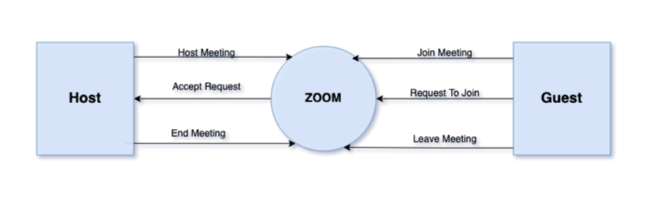

## 4.4: DFD Level 1

## 

## 4.5: DFD Level 2

## 

# 5: UML Diagrams

## 5.1: Activity Diagram

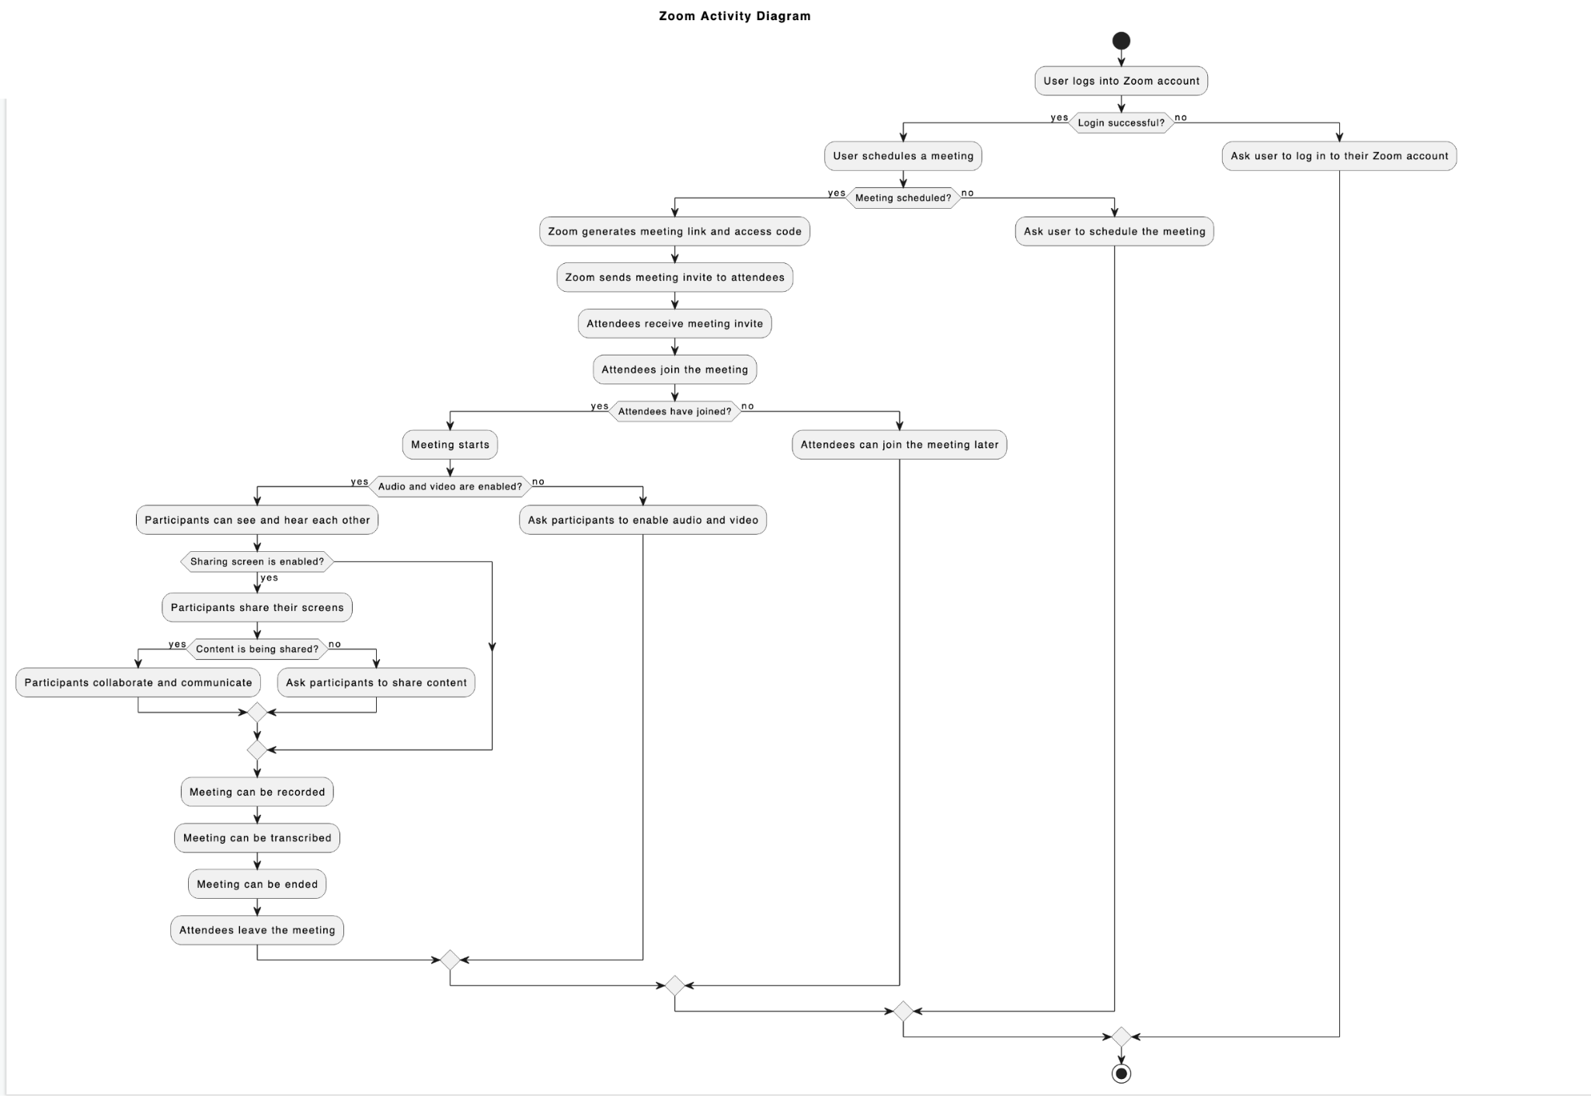

## 5.2: Use Case Diagram

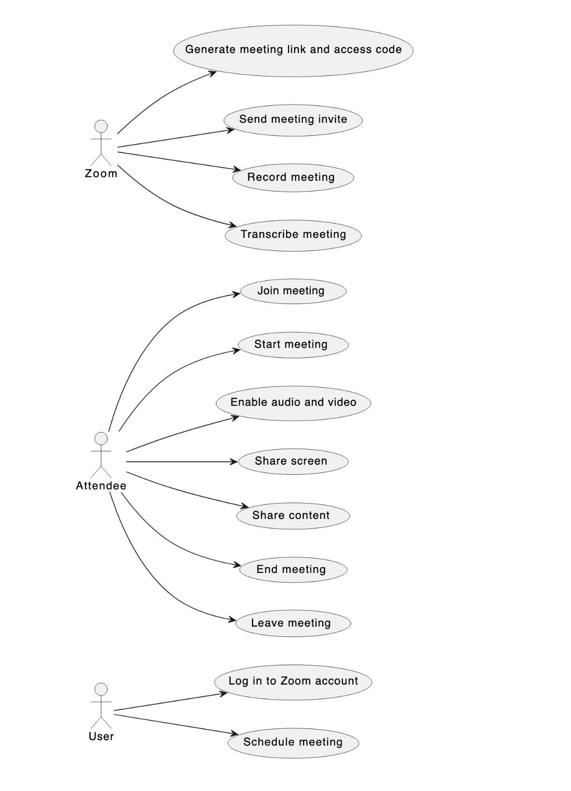

### 5.2.1 : Use Case Diagram (Textual Format)

| Use Case | Log in to Zoom account |
| --- | --- |
| Actors | User |
| Description | User wants to log in to their Zoom account. |
| Precondition | User has access to the Zoom account. |
| Basic Flow | * User opens the Zoom login page. * User enters their email address and password. * User clicks on the "Login" button. * Zoom verifies the email address and password. * Zoom redirects the user to their account dashboard. |
| Alternative Flow | If the email address and password are incorrect, Zoom displays an error message and prompts the user to enter the correct credentials. |
| Post Condition | User is logged in to their Zoom account and can access the account dashboard. |

| Use Case | Schedule meeting |
| --- | --- |
| Actors | User |
| Description | User wants to schedule a meeting on Zoom. |
| Precondition | User is logged in to their Zoom account. |
| Basic Flow | * User navigates to the "Schedule a Meeting" page. * User enters the meeting details, such as the meeting topic, date, time, and duration. * User clicks on the "Save" button. * Zoom saves the meeting details and generates a meeting link and access code. |
| Alternative Flow | If the user does not fill in all the required fields, Zoom displays an error message and prompts the user to fill in the missing details. |
| Post Condition | A meeting is scheduled, and a meeting link and access code are generated. |

| Use Case | Generate meeting link and access code |
| --- | --- |
| Actors | User,Zoom |
| Description | Zoom generates a unique meeting link and access code for each scheduled meeting. |
| Precondition | A meeting is scheduled. |
| Basic Flow | * Zoom generates a unique meeting link and access code for the scheduled meeting. |
| Alternative Flow | None. |
| Post Condition | A unique meeting link and access code are generated for the scheduled meeting. |

| Use Case | Send meeting invite |
| --- | --- |
| Actors | User |
| Description | User wants to send an invitation to attendees to join the scheduled meeting. |
| Precondition | A meeting is scheduled and a meeting link and access code are generated. |
| Basic Flow | * User navigates to the scheduled meeting page. * User clicks on the "Invite" button. * User enters the email addresses of the attendees. * User clicks on the "Send" button. * Zoom sends the meeting invitation email to the attendees. |
| Alternative Flow | If the user enters an incorrect email address, Zoom displays an error message and prompts the user to enter a correct email address. |
| Post Condition | The meeting invitation email is sent to the attendees. |

| Use Case | Join meeting |
| --- | --- |
| Actors | Attendee |
| Description | Attendee wants to join the scheduled meeting. |
| Precondition | The meeting link and access code are shared with the attendee. |
| Basic Flow | * Attendee clicks on the meeting link. * Attendee enters the meeting access code. * Attendee clicks on the "Join" button. * Zoom verifies the meeting access code. * Attendee joins the meeting. |
| Alternative Flow | If the meeting access code is incorrect, Zoom displays an error message and prompts the attendee to enter the correct access code. |
| Post Condition | Attendee joins the scheduled meeting. |

| Use Case | Enable audio and video |
| --- | --- |
| Actors | Attendee |
| Description | Attendee wants to enable audio and video during the meeting. |
| Precondition | Attendee is in the meeting. |
| Basic Flow | * Attendee clicks on the "Enable Audio/Video" button. * Zoom asks for permission to access the attendee's microphone and camera. * Attendee grants permission to Zoom. * Zoom enables the attendee's microphone and camera. |
| Alternative Flow | If the attendee denies permission to access their microphone and camera, Zoom displays an error message and prompts the attendee to grant permission. |
| Post Condition | Attendee's microphone and camera are enabled in the meeting. |

| Use Case | Share screen |
| --- | --- |
| Actors | Attendee |
| Description | Attendee wants to share their screen during the meeting. |
| Precondition | Attendee is in the scheduled meeting. |
| Basic Flow | * Attendee clicks on the "Share Screen" button. * Zoom asks for permission to access the attendee's screen. * Attendee grants permission to Zoom. * Zoom starts sharing the attendee's screen. |
| Alternative Flow | If the attendee denies permission to access their screen, Zoom displays an error message and prompts the attendee to grant permission. |
| Post Condition | Attendee's screen is being shared in the meeting. |

| Use Case | Share content |
| --- | --- |
| Actors | Attendee |
| Description | Attendee wants to share content, such as a file or a link, during the meeting. |
| Precondition | Attendee is in the scheduled meeting. |
| Basic Flow | * Attendee clicks on the "Share Content" button. * Attendee selects the content they want to share. * Attendee clicks on the "Share" button. * Zoom shares the content with all attendees in the meeting. |
| Alternative Flow | If the content is not supported by Zoom, Zoom displays an error message and prompts the attendee to share a supported content type. |
| Post Condition | Attendee's content is shared with all attendees in the meeting. |

| Use Case | Record meeting |
| --- | --- |
| Actors | User, Zoom |
| Description | User wants to record the meeting for future reference. |
| Precondition | User is in the scheduled meeting. |
| Basic Flow | * User clicks on the "Record" button. * Zoom starts recording the meeting. * User clicks on the "Stop Recording" button. * Zoom stops recording the meeting and saves the recording. |
| Alternative Flow | If the user does not have permission to record the meeting, Zoom displays an error message and prompts the user to request permission from the meeting host. |
| Post Condition | The meeting is recorded and saved for future reference. |

| Use Case | Transcribe meeting |
| --- | --- |
| Actors | Zoom |
| Description | Zoom wants to transcribe the recorded meeting. |
| Precondition | The meeting is recorded. |
| Basic Flow | * Zoom starts transcribing the recorded meeting. * Zoom saves the transcription. |
| Alternative Flow | If the recorded meeting is not clear, Zoom displays an error message and prompts the user to re-record the meeting. |
| Post Condition | The recorded meeting is transcribed and saved. |

| Use Case | End meeting |
| --- | --- |
| Actors | User |
| Description | User wants to end the scheduled meeting. |
| Precondition | The meeting is recorded. |
| Basic Flow | * User clicks on the "End Meeting" button. * Zoom asks for confirmation to end the meeting. * User confirms the end of the meeting. * Zoom ends the meeting and all attendees are disconnected. |
| Alternative Flow | None. |
| Post Condition | The scheduled meeting is ended, and all attendees are disconnected. |

| Use Case | Leave meeting |
| --- | --- |
| Actors | Attendee |
| Description | Attendee wants to leave the scheduled meeting. |
| Precondition | Attendee is in the scheduled meeting. |
| Basic Flow | * Attendee clicks on the "Leave Meeting" button. * Zoom asks for confirmation to leave the meeting. * Attendee confirms leaving the meeting. * Zoom disconnects the attendee from the meeting. |
| Alternative Flow | None. |
| Post Condition | The attendee leaves the scheduled meeting and is disconnected from the meeting. |

## 5.3: Sequence Diagram

## 

## 5.4: Class Diagram

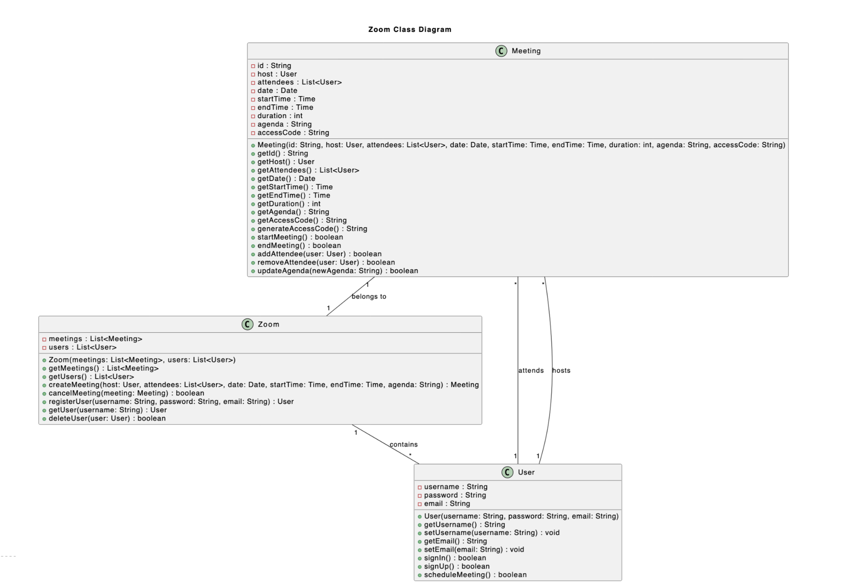

# 6 : Test Cases

Note

All the test cases presented in this document are based on the SRS (Software Requirements Specification), SA/SD (Structured Analysis and System Design), and UML (Unified Modeling Language) designs.

The purpose of these test cases is to verify that the Zoom system meets the requirements specified in the SRS, and that it functions as intended according to the SA/SD and UML designs. These test cases cover a wide range of scenarios and functionalities, and are designed to ensure that the Zoom system is thoroughly tested and validated.

There are around 20 test cases provided below

Test Cases

#### 1 : Log in to Zoom account

Description: User wants to log in to their Zoom account to access the platform's features. Preconditions: The user has a valid Zoom account.

Test Steps:

1. Enter the Zoom website's URL in a web browser.
2. Click on the "Log in" button on the homepage.
3. Enter the registered email address and password in the required fields.
4. Click on the "Sign In" button.

Expected Results:

* Users should be successfully logged in to their Zoom account.
* Users should have access to all the features associated with their Zoom account.

Test Data:

* Valid registered email address and password.

Test Environment:

* Desktop computer or mobile device with a web browser.
* Stable internet connection.

Test Results:

* Pass: User was able to log in to their Zoom account successfully.
* Fail: User was unable to log in to their Zoom account due to incorrect login credentials.

#### 2 : Schedule meeting

Description: User wants to schedule a meeting on the Zoom platform. Preconditions: The user has a valid Zoom account and is logged in.

Test Steps:

1. Click on the "Schedule a Meeting" button on the Zoom dashboard.
2. Fill in the meeting details, including the date, time, and duration.
3. Add any additional meeting options, such as password protection or waiting room.
4. Click on the "Schedule" button.

Expected Results:

* Meeting should be successfully scheduled and saved to the user's Zoom account.
* Meeting details should be displayed to the user.

Test Data:

* Meeting date, time, and duration.
* Additional meeting options, such as password protection or waiting room.

Test Environment:

* Desktop computer or mobile device with a web browser.
* Stable internet connection.

Test Results:

* Pass: User was able to schedule the meeting successfully.
* Fail: User was unable to schedule the meeting due to errors in meeting details or technical issues with the platform.

#### 3 : Join Meeting

Description: This use case allows attendees to join a Zoom meeting hosted by the user. Preconditions: The user must have scheduled the meeting and shared the meeting link or access code with the attendees.

Test Steps:

1. Attendee clicks on the meeting link or enters the access code provided by the user.
2. Attendee enters their name and email address.
3. Attendee selects whether to join with computer audio or phone audio.
4. Attendee clicks on "Join Meeting" button.

Expected Results:

1. Attendee is redirected to the Zoom meeting page.
2. Attendee's name and email address is displayed in the list of attendees.
3. Attendee's audio is enabled according to their selection.
4. Attendee is successfully joined to the meeting.

Test Data:

* Meeting link:<https://zoom.us/j/1234567890>
* Access code: 123456
* Attendee name: John Smith
* Attendee email: john.smith@example.com

Test Environment:

* Operating system: Windows 10
* Browser: Google Chrome v.92

Test Results:

* Test case passed: All steps executed as expected, attendee successfully joined the meeting.
* Test case failed: Attendee was not able to join the meeting, encountered an error message.

#### 4 : Generate Meeting Link and Access Code

Description: As a user of Zoom, I want to generate a unique meeting link and access code for my scheduled meeting so that only authorized attendees can join the meeting. Preconditions: The user must be logged in to their Zoom account and have scheduled a meeting.

Test Steps:

1. Navigate to the scheduled meeting in the Zoom account.
2. Click on the "Generate meeting link and access code" option.
3. Verify that a unique meeting link and access code are generated.

Expected Results: The system should generate a unique meeting link and access code for the scheduled meeting.

Test Data:

* Meeting scheduled for May 10th at 10:00am
* User with a Basic Zoom account

Test Environment:

* Zoom desktop application on Windows 10
* Zoom web application on Google Chrome browser

Test Results:

* Pass: A unique meeting link and access code are generated.
* Fail: Meeting link and/or access code are not unique or are not generated.

#### 5 : Send Meeting Invite

Description: As a user of Zoom, I want to send a meeting invite to attendees so that they can join the scheduled meeting. Preconditions: The user must be logged in to their Zoom account and have scheduled a meeting.

Test Steps:

1. Navigate to the scheduled meeting in the Zoom account.
2. Click on the "Send meeting invite" option.
3. Enter the email addresses of the attendees.
4. Click on the "Send" button.
5. Verify that the meeting invite has been sent to the attendees.

Expected Results: The system should send the meeting invite to the specified email addresses.

Test Data:

* Meeting scheduled for May 10th at 10:00am
* Attendees: john@example.com, jane@example.com
* User with a Basic Zoom account

Test Environment:

* Zoom desktop application on Windows 10
* Zoom web application on Google Chrome browser

Test Results:

* Pass: Meeting invite is sent to the specified email addresses.
* Fail: Meeting invite is not sent or is sent to the wrong email addresses.

#### 6 : Enable Audio and Video

Description: As an attendee of a Zoom meeting, I want to enable my audio and video so that I can participate in the meeting. Preconditions: The attendee must have joined the meeting.

Test Steps:

1. Click on the "Join Audio" button.
2. Select the "Computer Audio" option.
3. Verify that the audio is enabled.
4. Click on the "Start Video" button.
5. Verify that the video is enabled.

Expected Results: The system should enable the attendee's audio and video for the meeting.

Test Data:

* Meeting scheduled for May 10th at 10:00am
* Attendee with a Basic Zoom account

Test Environment:

* Zoom desktop application on Windows 10
* Zoom web application on Google Chrome browser

Test Results:

* Pass: Audio and video are enabled for the attendee.
* Fail: Audio or video is not enabled for the attendee.

#### 7 : Start Meeting

Description: This use case describes the process of starting a scheduled Zoom meeting. Preconditions: A scheduled Zoom meeting exists.

Test Steps:

1. Login to Zoom account.
2. Click on the "Meetings" tab.
3. Click on the scheduled meeting that needs to be started.
4. Click on the "Start" button.
5. Wait for the meeting to start.

Expected Results: The scheduled meeting should start successfully and the host should be able to see the attendees in the meeting.

Test Data: Meeting ID: 1234567890 Meeting Password: mypassword

Test Environment: Zoom desktop application version 5.7.0 on Windows 10.

Test Results: The scheduled meeting started successfully and the host was able to see the attendees in the meeting.

#### 8 : Share Screen

Description: This use case describes the process of sharing the screen in a Zoom meeting. Preconditions: A Zoom meeting is ongoing.

Test Steps:

1. Click on the "Share Screen" button in the meeting controls.
2. Choose the screen that needs to be shared.
3. Click on "Share".

Expected Results: The selected screen should be shared with the meeting attendees and they should be able to see it.

Test Data: Screen resolution: 1920x1080

Test Environment: Zoom desktop application version 5.7.0 on macOS.

Test Results: The selected screen was shared successfully with the meeting attendees and they were able to see it.

#### 9 : Record Meeting

Description: This use case describes the process of recording a Zoom meeting. Preconditions: A Zoom meeting is ongoing.

Test Steps:

1. Click on the "Record" button in the meeting controls.
2. Choose to record the meeting locally or to the cloud.
3. Wait for the meeting to finish.
4. Stop the recording.

Expected Results: The meeting should be recorded successfully and the recording should be saved either locally or in the cloud.

Test Data: Recording mode: Local recording Recording format: MP4

Test Environment: Zoom desktop application version 5.7.0 on Windows 10.

Test Results: The meeting was recorded successfully in MP4 format and saved locally on the host's computer.

#### 10 : Transcribe Meeting

Description: The user wants to transcribe the meeting to have a written record of the discussion. Preconditions:

* The user must be logged into their Zoom account.
* A meeting must have been conducted and recorded.

Test Steps:

1. Login to Zoom account.
2. Navigate to the recorded meeting.
3. Click on the "Transcribe" button.
4. Wait for the transcription process to complete.
5. Check the accuracy of the transcribed text.
6. Save the transcribed text to a file.

Expected Results:

* The "Transcribe" button is visible and clickable.
* The transcription process completes successfully.
* The transcribed text is accurate.
* The transcribed text is saved to a file.

Test Data:

* Meeting ID: 123456789
* Meeting recording file: recording.mp4

Test Environment:

* Device: Windows 10
* Browser: Google Chrome
* Zoom version: 5.8.0

Test Results:

* The "Transcribe" button was visible and clickable.
* The transcription process completed successfully within 15 minutes.
* The transcribed text was accurate with only a few minor errors.
* The transcribed text was saved to a file in the desired location.

#### 11 : End Meeting

Description: The user wants to end the ongoing meeting. Preconditions:

* The user must be logged into their Zoom account.
* A meeting must be ongoing.

Test Steps:

1. Login to Zoom account.
2. Navigate to the ongoing meeting.
3. Click on the "End Meeting" button.
4. Confirm the decision to end the meeting.
5. Verify that the meeting has ended.

Expected Results:

* The "End Meeting" button is visible and clickable.
* A confirmation prompt appears before ending the meeting.
* The meeting ends immediately after confirmation.

Test Data:

* Meeting ID: 987654321

Test Environment:

* Device: Macbook Pro
* Browser: Safari
* Zoom version: 5.9.0

Test Results:

* The "End Meeting" button was visible and clickable.
* The confirmation prompt appeared as expected.
* The meeting ended immediately after confirmation without any issues.

#### 12 : Leave Meeting

Description: The attendee wants to leave the ongoing meeting. Preconditions:

* The attendee must have joined the ongoing meeting.

Test Steps:

1. Click on the "Leave Meeting" button.
2. Confirm the decision to leave the meeting.
3. Verify that the attendee has left the meeting.

Expected Results:

* The "Leave Meeting" button is visible and clickable.
* A confirmation prompt appears before leaving the meeting.
* The attendee leaves the meeting immediately after confirmation.

Test Data:

* Meeting ID: 555666777
* Attendee Name: John Smith

Test Environment:

* Device: iPhone 12
* Browser: Safari
* Zoom app version: 5.9.5

Test Results:

* The "Leave Meeting" button was visible and clickable.
* The confirmation prompt appeared as expected.
* The attendee left the meeting immediately after confirmation without any issues.

#### 13: Change Video Layout

Description: As a host, I want to be able to change the video layout of my Zoom meeting, so that I can adjust the appearance of the meeting as needed.

Preconditions:

* User has logged in to their Zoom account.
* User has scheduled a meeting.
* User has started the meeting.

Test Steps:

1. Click on the "Video Layout" button in the Zoom meeting toolbar.
2. Select a video layout option from the dropdown menu.
3. Observe the video layout change in the meeting window.

Expected Results:

* The "Video Layout" button should be clickable and visible in the meeting toolbar.
* The dropdown menu should contain several video layout options to choose from.
* The selected video layout should be applied to the meeting window, with participant video feeds rearranged according to the chosen layout.

Test Data:

* Zoom meeting ID
* Zoom meeting password (if applicable)

Test Environment:

* Zoom desktop client
* Zoom meeting with multiple participants

Test Results:

* Pass: The video layout button is clickable, the dropdown menu contains several options, and the selected layout is applied to the meeting window.
* Fail: The video layout button is not visible or clickable, the dropdown menu does not contain any options, or the selected layout is not applied to the meeting window.

#### 14 : Change Meeting Settings

Description: As a user, I want to be able to change the settings of a scheduled meeting. Preconditions: User is logged in to their Zoom account and has a scheduled meeting.

Test Steps:

1. Navigate to the scheduled meeting on the user's Zoom account dashboard.
2. Click on the "Settings" option for the scheduled meeting.
3. Change any desired settings, such as the meeting duration or participant permissions.
4. Save the changes.

Expected Results: The meeting settings should be successfully changed and saved.

Test Data: A scheduled meeting with default settings.

Test Environment: Zoom web application.

Test Results: The meeting settings are successfully changed and saved.

#### 15 : Mute All Participants

Description: As a meeting host, I want to be able to mute all participants in the meeting. Preconditions: User is logged in to their Zoom account and has started a meeting with multiple participants.

Test Steps:

1. Click on the "Manage Participants" button on the meeting toolbar.
2. Click on the "Mute All" button on the bottom of the participants list.
3. Confirm the action.
4. Verify that all participants have been muted.

Expected Results: All participants in the meeting should be successfully muted.

Test Data: A meeting with multiple participants.

Test Environment: Zoom desktop application.

Test Results: All participants are successfully muted.

Use Case Name: Record and Share Meeting Description: As a user, I want to be able to record a meeting and share the recording with other attendees. Preconditions: User is logged in to their Zoom account and has started a meeting.

Test Steps:

1. Click on the "Record" button on the meeting toolbar.
2. Choose whether to record locally or to the cloud.
3. Start the recording.
4. End the recording.
5. Navigate to the recorded meeting in the user's Zoom account dashboard.
6. Click on the "Share" button for the recorded meeting.
7. Enter the email addresses of the attendees to share the recording with.
8. Send the recording to the attendees.

Expected Results: The meeting recording should be successfully shared with the specified attendees.

Test Data: A meeting with at least one attendee.

Test Environment: Zoom web application.

Test Results: The meeting recording is successfully shared with the specified attendees.

#### 16 : Change Audio Settings

Description: As a user, I want to be able to change the audio settings for a meeting. Preconditions: User is logged in to their Zoom account and has started a meeting.

Test Steps:

1. Click on the "Audio Settings" button on the meeting toolbar.
2. Change any desired audio settings, such as the speaker or microphone device.
3. Save the changes.

Expected Results: The audio settings for the meeting should be successfully changed and saved.

Test Data: A meeting with default audio settings.

Test Environment: Zoom desktop application.

Test Results: The audio settings for the meeting are successfully changed and saved.

#### 17 : Manage Participants

Description: User can manage participants during a meeting Preconditions: User has started a meeting with at least one attendee

Test Steps:

1. User clicks on the "Manage Participants" button
2. User removes one participant from the meeting
3. User adds a new participant to the meeting
4. User changes the role of a participant from attendee to co-host

Expected Results:

1. The "Manage Participants" window opens
2. The selected participant is removed from the meeting and can no longer participate
3. The new participant is added to the meeting and can participate
4. The selected participant's role is changed from attendee to co-host and they have additional permissions in the meeting

Test Data:

* Meeting with 5 attendees
* New participant email address

Test Environment:

* Zoom desktop application on Windows 10

Test Results:

* All steps pass, the user is able to manage participants as expected

#### 18 : Share Video Clip

Description: User can share a video clip with meeting attendees Preconditions: User has started a meeting

Test Steps:

1. User clicks on the "Share Screen" button
2. User selects the option to share a video clip
3. User selects a video clip to share from their local device
4. User plays the video clip and confirms it is successfully shared with attendees

Expected Results:

1. The "Share Screen" window opens
2. The user selects the option to share a video clip
3. The user selects a video clip to share and it is successfully loaded
4. The video clip plays and is successfully shared with attendees

Test Data:

* Video clip saved on user's local device

Test Environment:

* Zoom desktop application on macOS

Test Results:

* All steps pass, the user is able to share a video clip with meeting attendees

#### 19 : Share Whiteboard

Description: User can share a whiteboard with meeting attendees Preconditions: User has started a meeting

Test Steps:

1. User clicks on the "Share Screen" button
2. User selects the option to share a whiteboard
3. User draws on the whiteboard and confirms it is successfully shared with attendees

Expected Results:

1. The "Share Screen" window opens
2. The user selects the option to share a whiteboard
3. The user is able to draw on the whiteboard and attendees are able to see the changes in real-time

Test Data: None

Test Environment:

* Zoom web application on Google Chrome browser

Test Results:

* All steps pass, the user is able to share a whiteboard with meeting attendees

#### 20 : Share Virtual Background

Description: As a participant, I want to be able to share a virtual background in my Zoom meeting, so that I can personalize my appearance during the meeting.

Preconditions:

* User has logged in to their Zoom account.
* User has joined a meeting.

Test Steps:

1. Click on the "Virtual Background" button in the Zoom meeting toolbar.
2. Select a virtual background from the available options.
3. Observe the virtual background applied to the user's video feed.

Expected Results:

* The "Virtual Background" button should be clickable and visible in the meeting toolbar.
* The available virtual background options should be displayed, and the user should be able to select one.
* The selected virtual background should be applied to the user's video feed.

Test Data:

* Zoom meeting ID
* Zoom meeting password (if applicable)

Test Environment:

* Zoom desktop client
* Zoom meeting with multiple participants

Test Results:

* Pass: The virtual background button is clickable, the available options are displayed, and the selected virtual background is applied to the user's video feed.
* Fail: The virtual background button is not visible or clickable, the available options are not displayed, or the selected virtual background is not applied to the user's video feed.

THE END